Inauguration report Date: 25th Jan 2024
Incubation Centre in government College Barwala Panchkula has been inaugurated by Shri Rajiv Ratan director General, higher education, Haryana on 25th of Jan 2024. In his address. He said that this Centre will provide significant opportunities for students in the region. It show a commitment to fostering innovation and entrepreneurship within the community

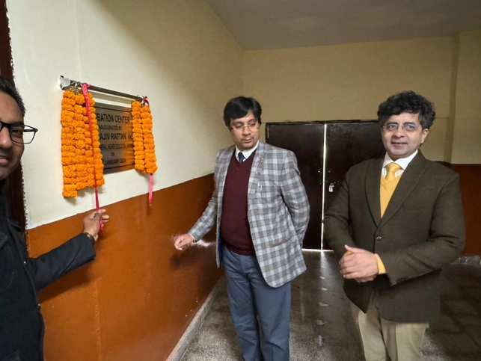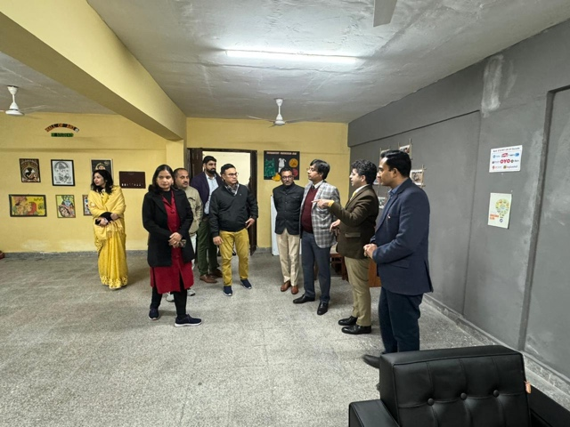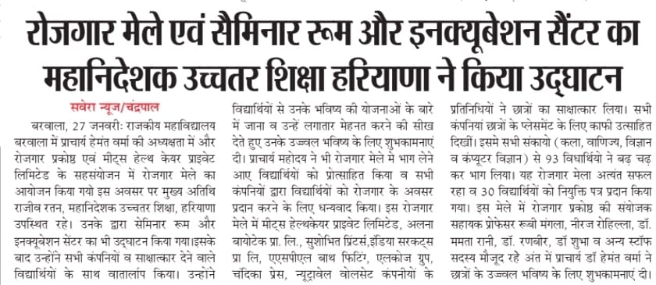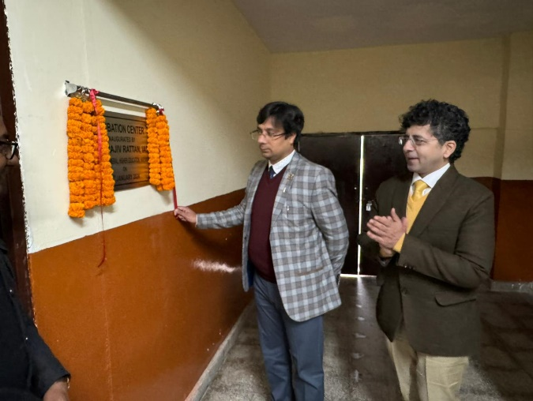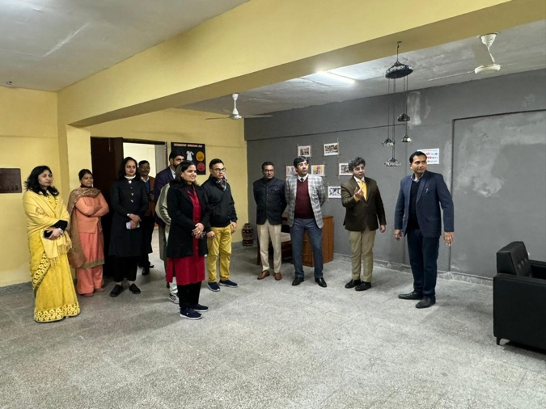

Activity 1 report Date: 5th Feb 2024
Incubation centre committee has organised a one-day workshop with incubation centre government PG College Sector 1 under chairmanship of principal Dr Hemant Verma on 5th of Feb, 2024, the distinguished guest were Mrs Indra Sharma, Dr Meenakshi Singh and Mrs Anjali Sewa, Dipti, Director, higher education, Haryana, a total of 50 students actively participated in the workshop Miss Tanushree and Mr Pankaj from incubation Centre government PG College sector one Panchkula, let this workshop, they encourage students to share their innovative ideas and fostering entrepreneur spirit among the attendees focusing on the entrepreneur development of students, they guided students how they can implement their ideas. At the end student share ideas they have and asked about how they can Overcome the shortcomings of resources.
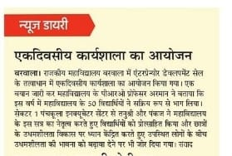
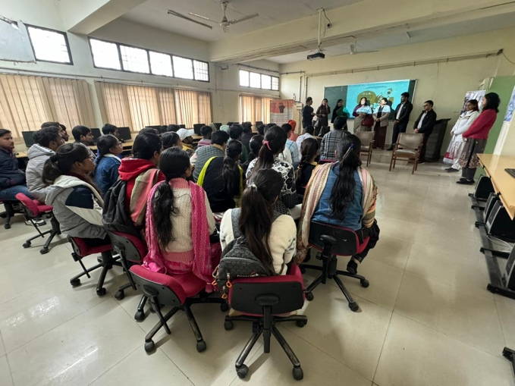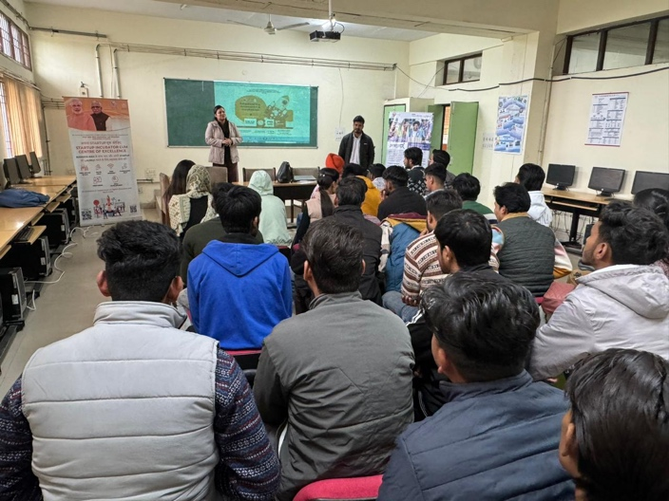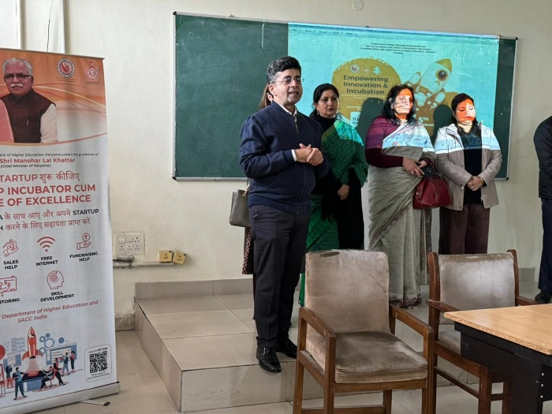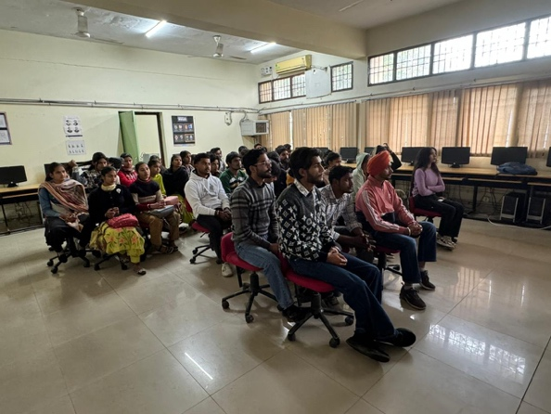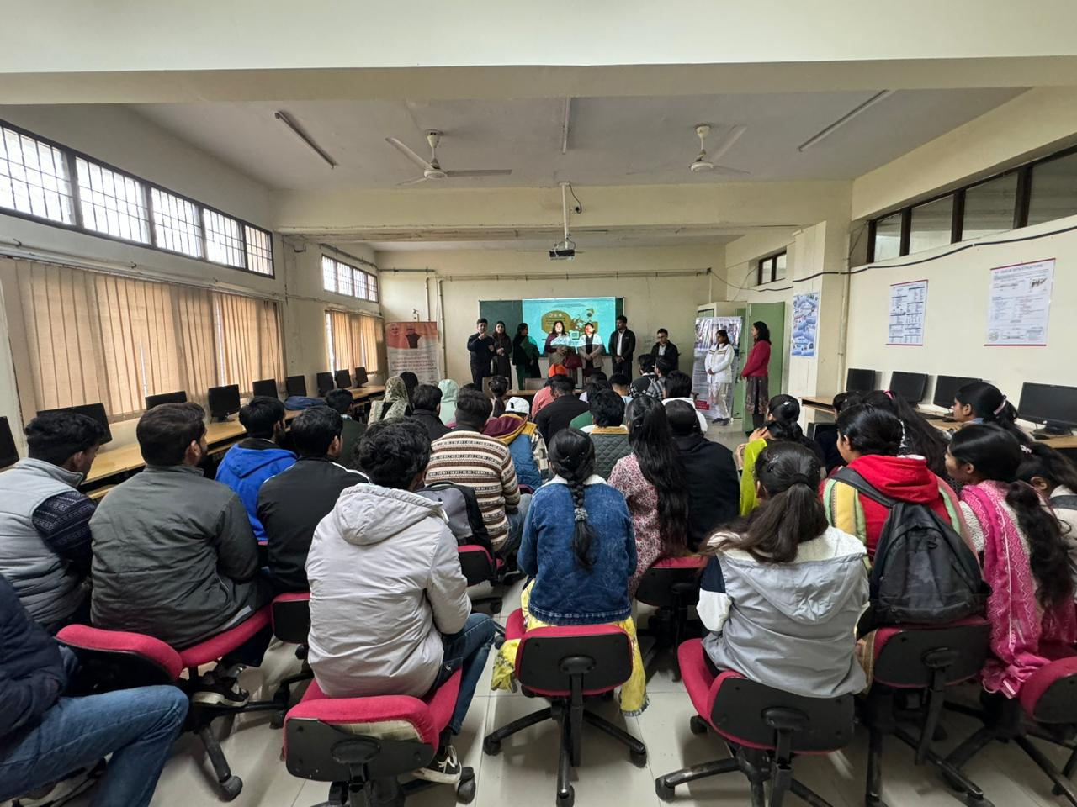

Activity 2 report Date: 22 March 2024
Motivational lecture for students, Rang Srijan organised by incubation Centre of government College, Barwala Panchkula, under the esteemed guidance of principal, Dr Hemant Verma on 22nd of March 2024, Speaker Mr. Gautam Sharma from Surya chemical Company delivered an inspiring lecture to the students, encouraging them to consider entrepreneurship and providing insights into starting a start-up in the future. He emphasise the importance of innovation, preserve, and strategic planning in navigating the challenges of entrepreneurship. Ideas from students were welcomed and four students, Miss Vinny of BSc final Mr Gaurav of Bca, final Miss Haritha become third and Mr Munish of Bca, third have been awarded certificates for this.
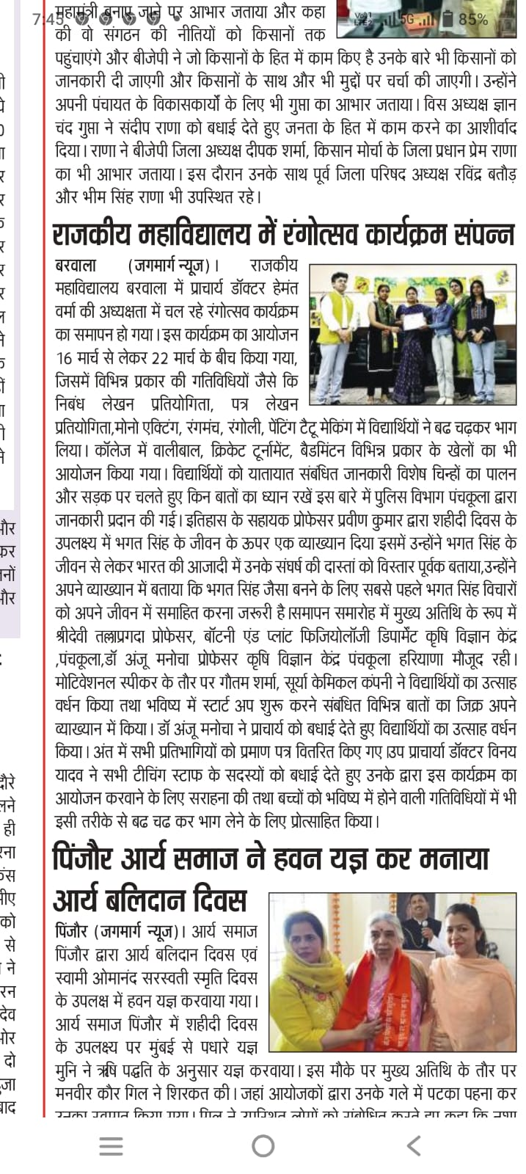

Activity 3 report Date:
Incubation centre of government College Barwala Panchkula organised a special session of Mr Vineet Khurana from incubation Centre at government PG College sector 1, Panchkula, the event was led by principal Dr Hemant Verma, Mr Khurana shared his life experiences with the students and talked about how important it is to learn from failures in life, specially when starting a business he said that problems must be identified before starting a business students. Interestingly took part in talk. Many of them fell inspired to start their business after hearing, Mr. Khurana experiences, incubation Centre committee members, Mrs Sandhya, Miss Seema and Mr Parveen also attended the session to support the students. The talk by Mr. Khurana approved a great boost for students, encouraging them to think about starting their own business and showing them that it is possible to overcome challenges and achieve success. It is part of the college effort to help students become innovative and rising in their future

Activity 4 report Date: 26 Apr 2025
Government College Barwala incubation department recently took eight students to incubation Centre in government College sector one Panchkula, the goal is to help the students turn their artistic talents into business ideas to faculty members, Miss Seema and Miss Sandhya from the computer science department, accompanied the students during the visit, the students learn how to share their creative skills into practical business plans. Principal, Dr Hemant Verma played a crucial role in guiding and supporting the students . All eight students were girls showing the colleges dedication to empowering women in entrepreneurship, their excitement and dedication to start. Their own business were evident after their visit. The student return to college with new found confidence and enthusiasm to pursue their Entrepreneur dreams.
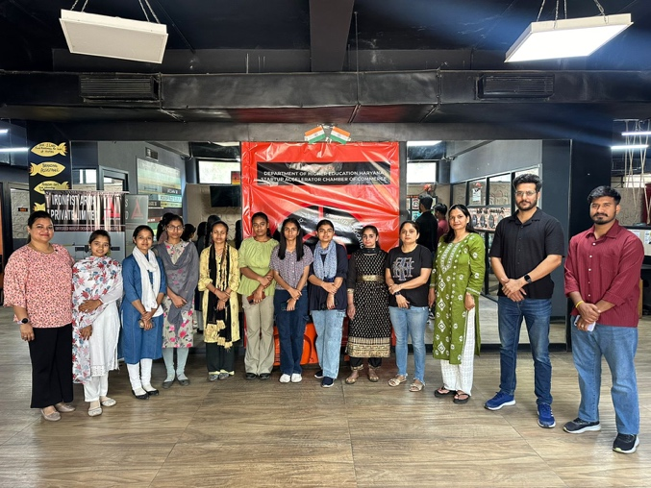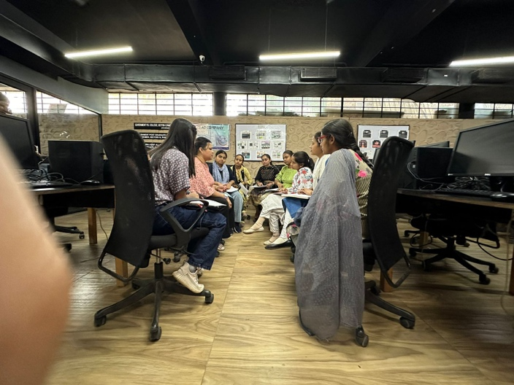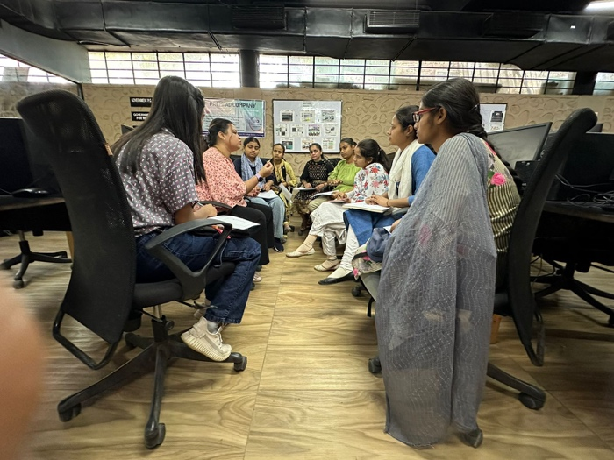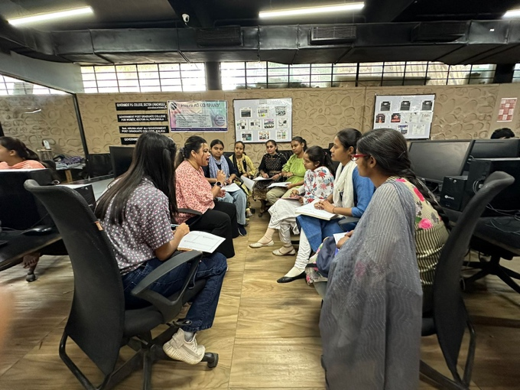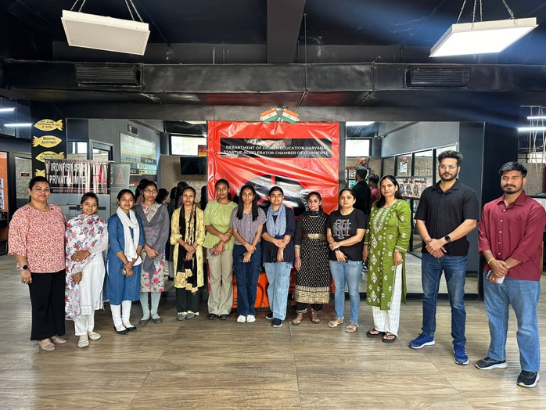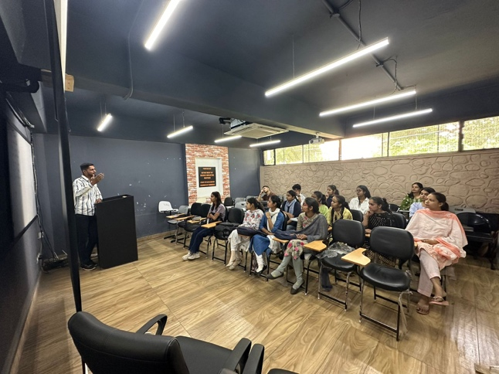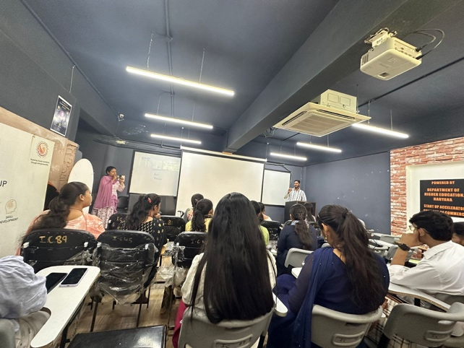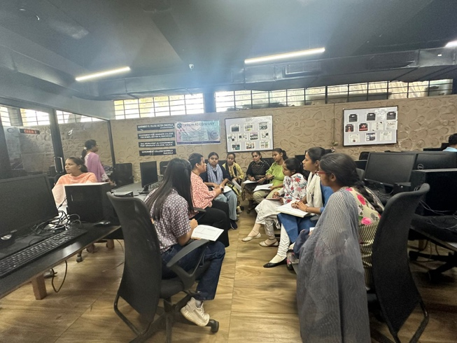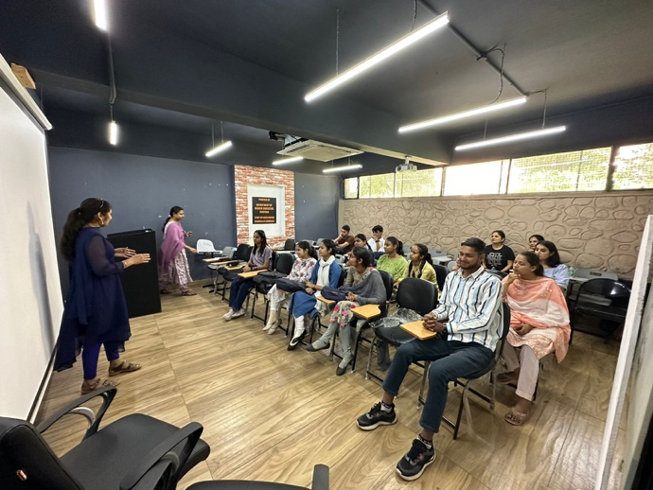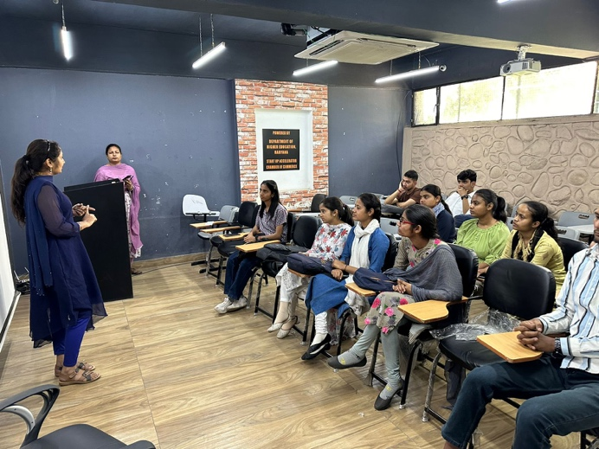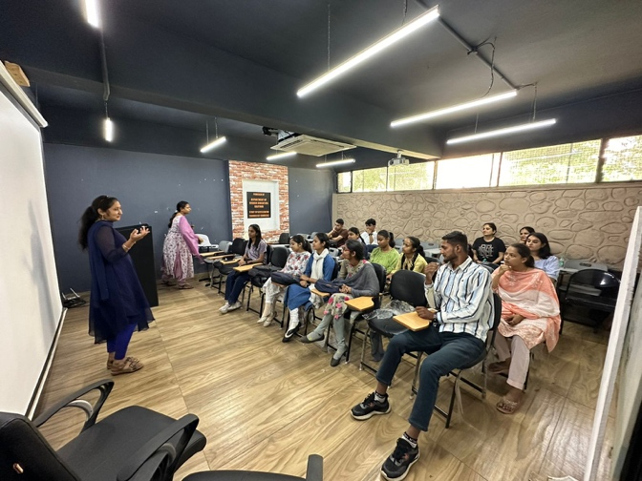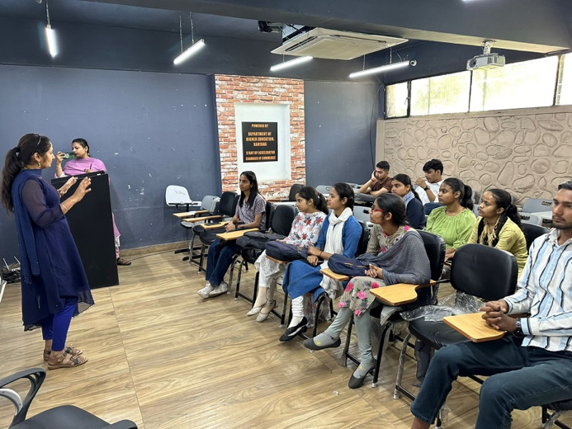

Activity 5 report Date: 25 June
Students of government College Barwala attended ideaKriti program in government, College sector one, Panchkula
Programme is designed to help you turn your ideas into successful businesses. This was five days program and six students attended it.
Students were introduced to various skills and terms related to start-ups. How to start your business. What qualities are needed for a successful entrepreneur? What are the market needs and validation, etc students learn many things from this workshop and were happy to attend.
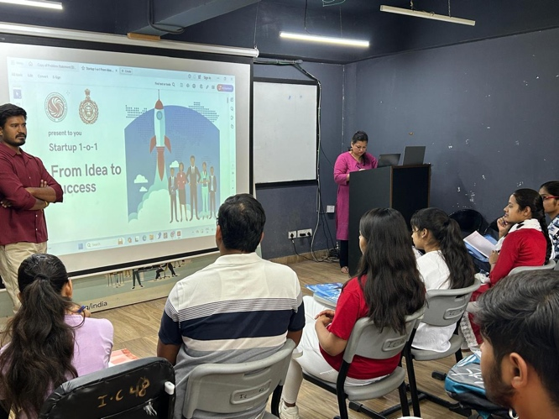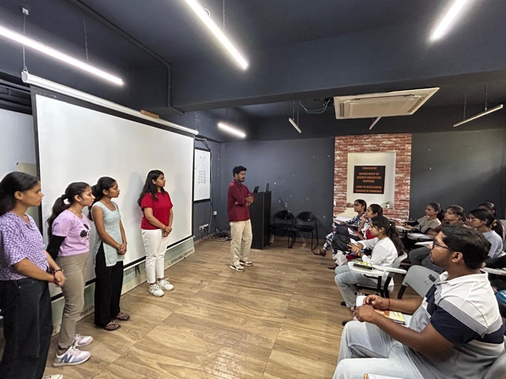

Activity 6 report Date: 15 July 2024
On 15th July 2024 Tanushree mam from incubation Centre government PG College sector 1, Panchkula visited our college to interact with students and share her insights on start-ups during the session. She discussed the challenges of starting one’s own business and encouraged the student to think creatively about their own product ideas .
Asked Student to develop a sample product and estimate its cost, selling price, customer base marketplace and other relevant details. This exercise helped the students gain a comprehensive understanding of their product and business.
Seven girls students interact with mam and found this session, informative and fruitful. This session aims to inspire and educate the students about the possibilities of entrepreneurship and importance of practical experience in turning their ideas into reality.

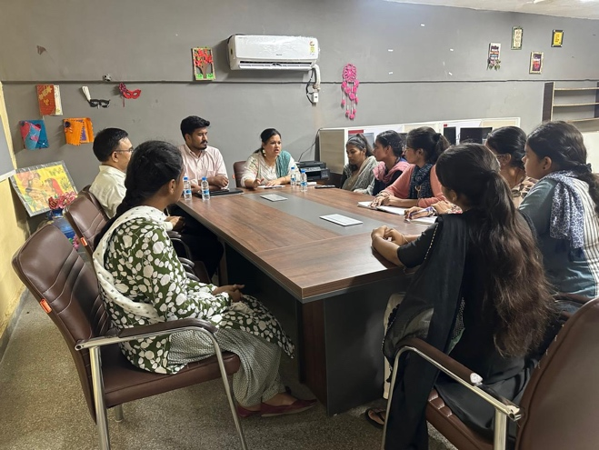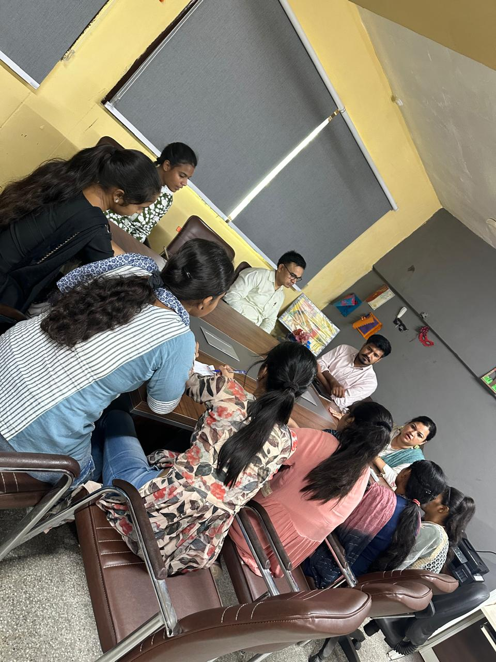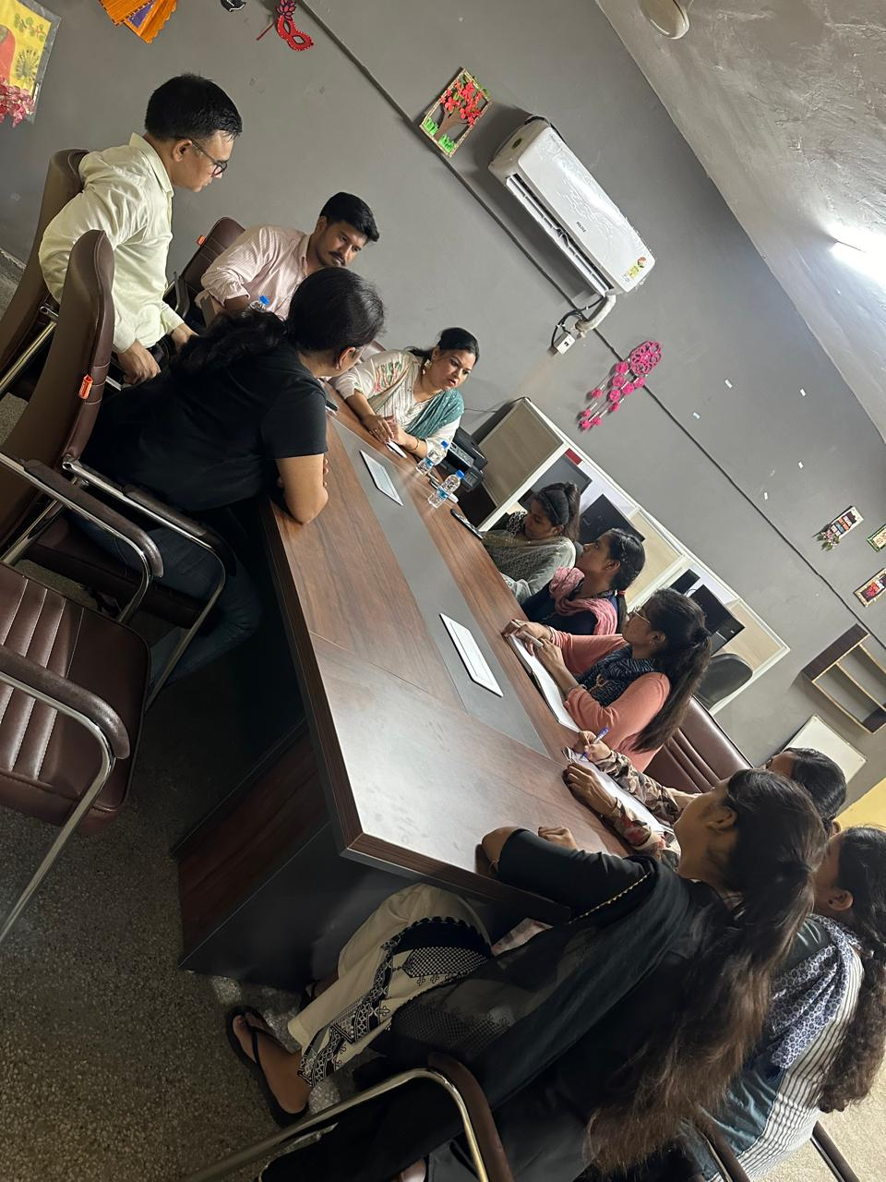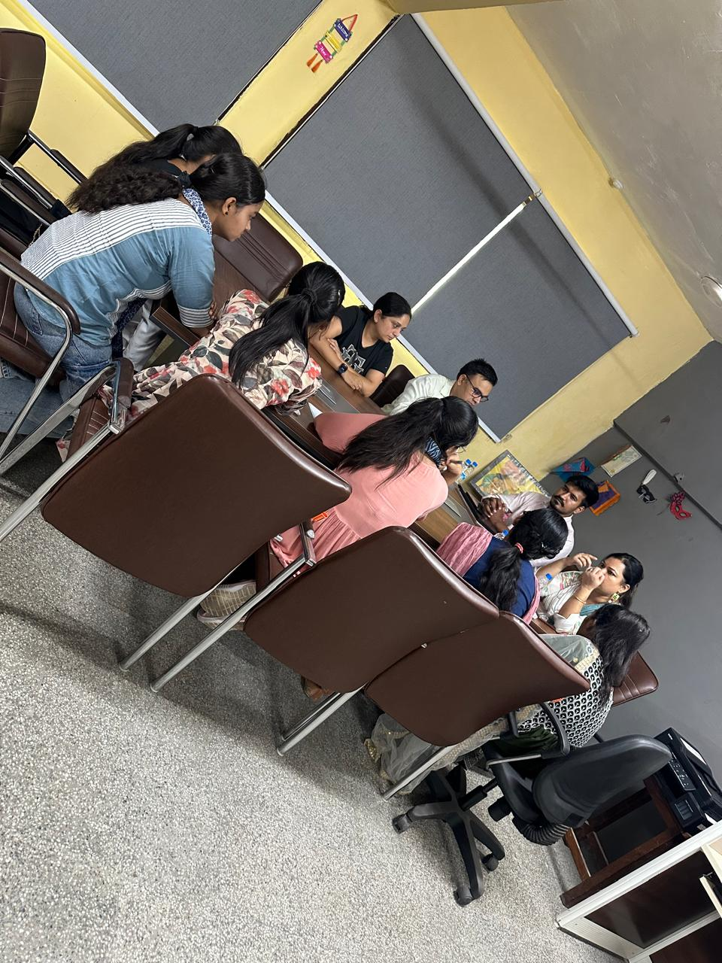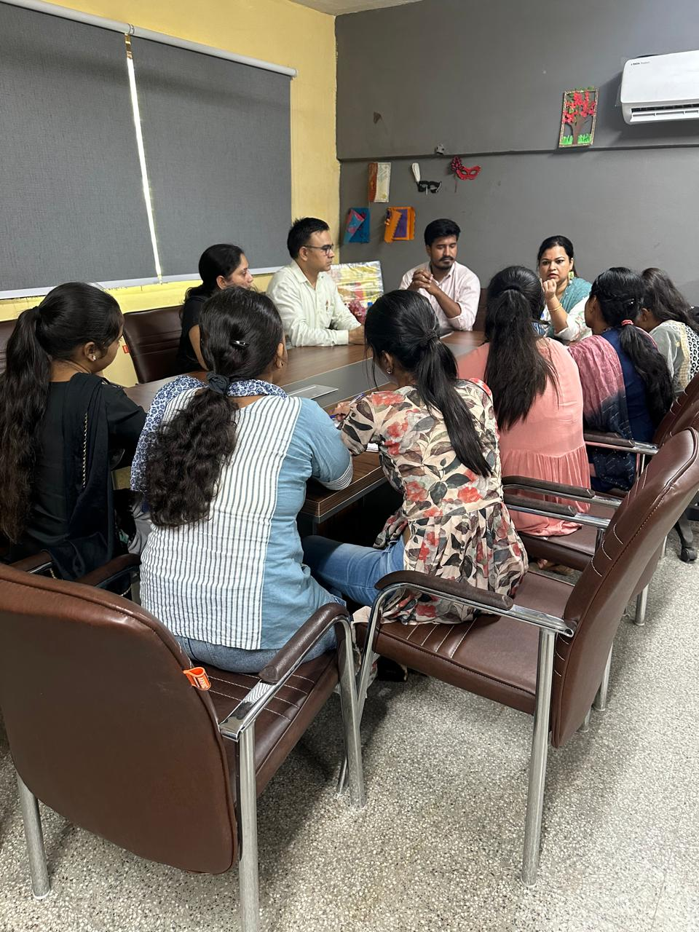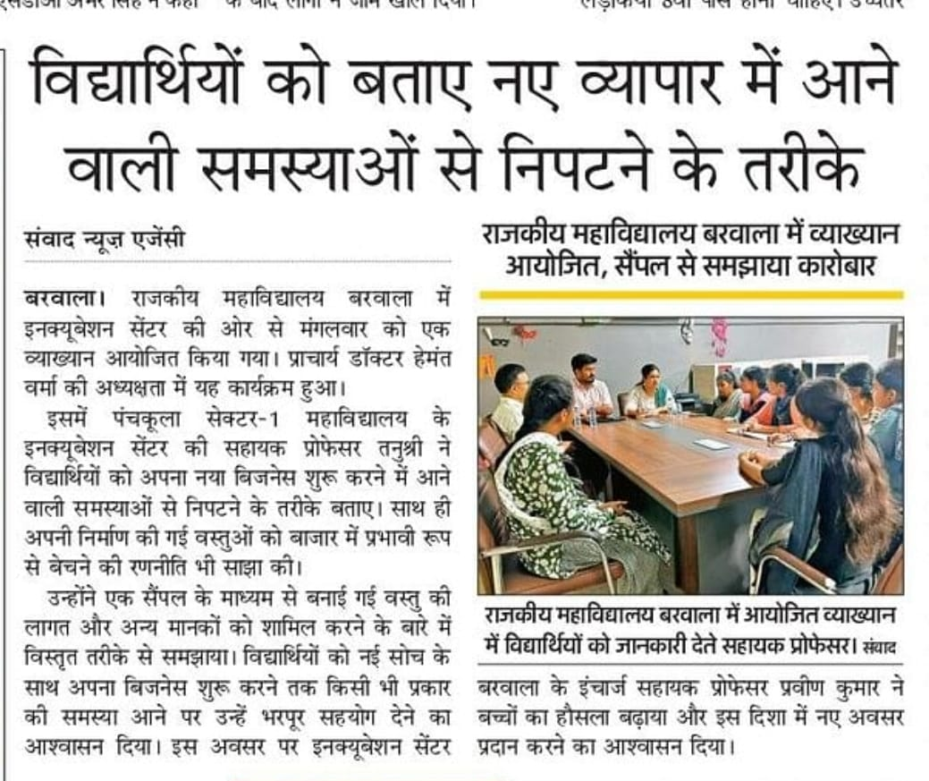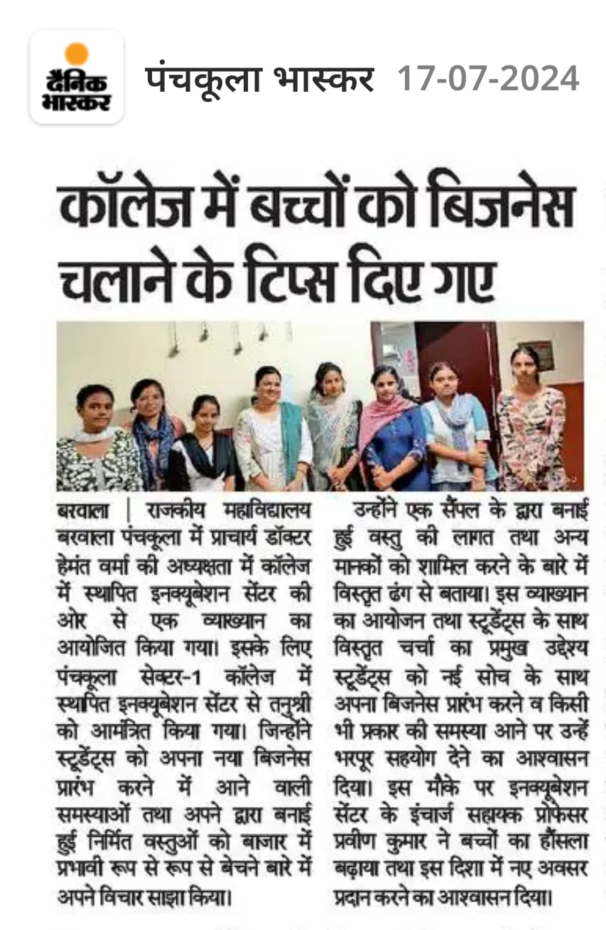

Activity 7 report Date:
Tanushree mam visited and interact with students and check their product sample. He discussed each product, cross con and marketplace. Five students brought their sample and it was discussed how to improve the product and how to lessen the cost so that students can compete in the market.
Students cleared their queries and get more clear vision about their product and marketplace. Moreover, she guided students how to do teamwork as a business team is needed. Also see our students to prepare few samples so that in future students can showcase their products in the market and she will help them by tying up and collaborator who do exhibitions.

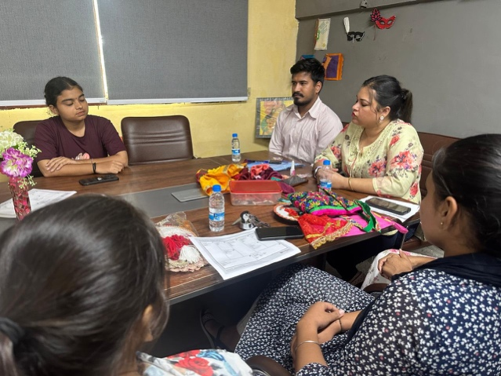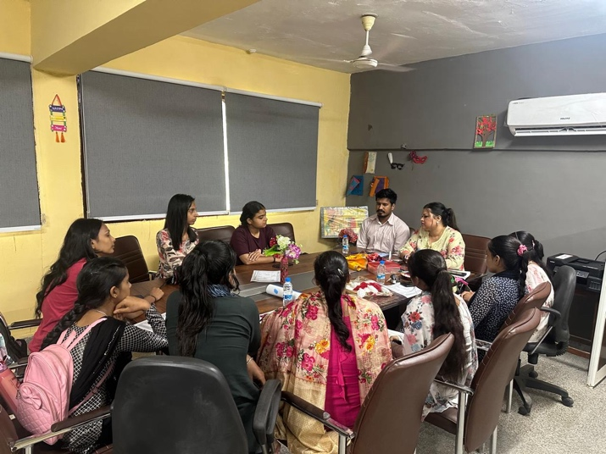
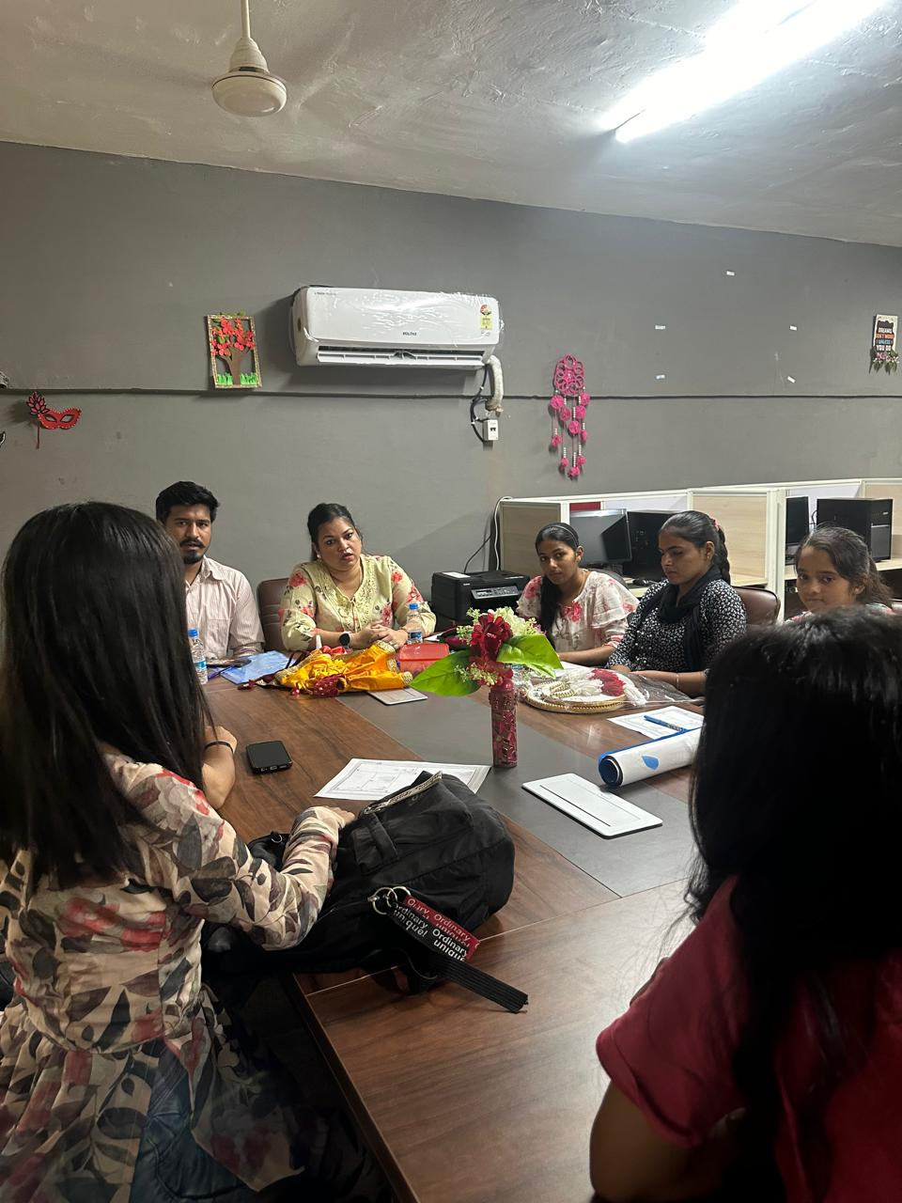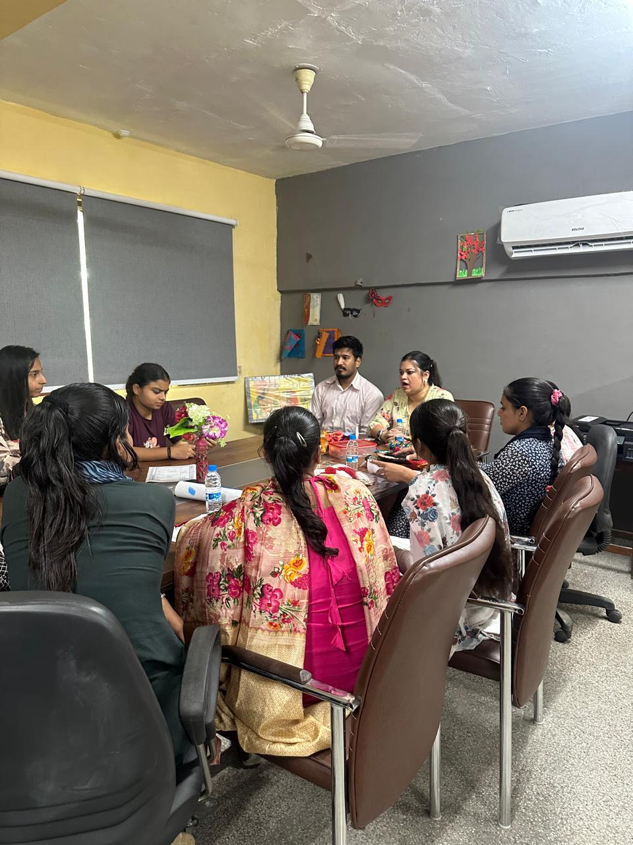
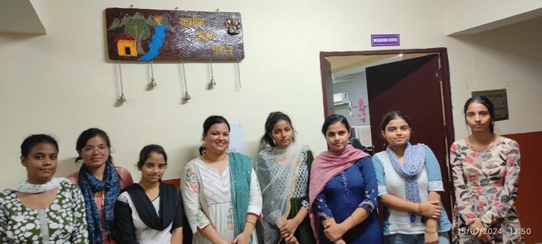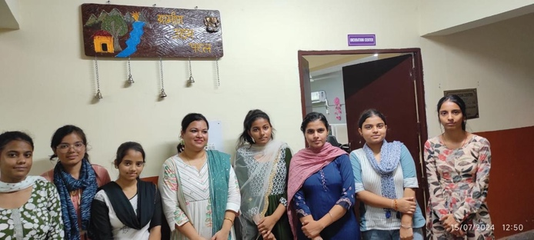

Activity 8 report Date:
A workshop was organised in the incubation centre. In this workshop, the female students learn the art of crochet weaving.Dr Vinay yadav encouraged the students and wish them a bright future.
On this occasion, Mr Parveen from history department shared about the history of textiles in India, explaining how the British came to India for its fabrics, took control of the country and exported cotton setting up large factories in London and earning huge profit. Miss Seema Grewal incharge of incubation Centre addressed the students and said that handicrafts are important part of our culture and should be preserved. She added nowadays, children waste time watching and making reels on mobile phones which increase mental stress, whereas working with the ones hand help reduce Stress .
On this occasion, students of Sri Senior secondary school, wali Panchkula visited the workshop and learn from mrs Seema and Mrs Chanchal from Barwala, who were skilled in crochet work, taught students how to make items using crochet . This work, not only helps children earn money, but also keeps them away from mobile phone.

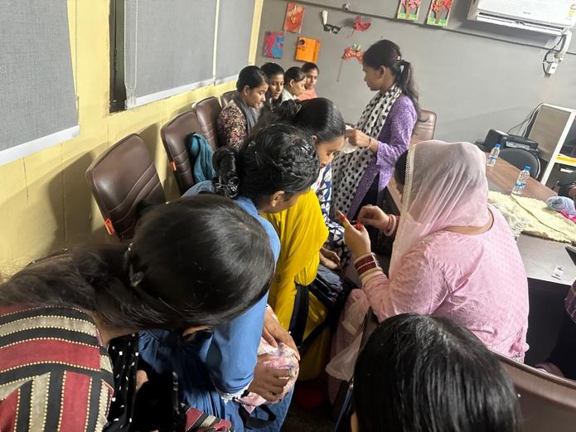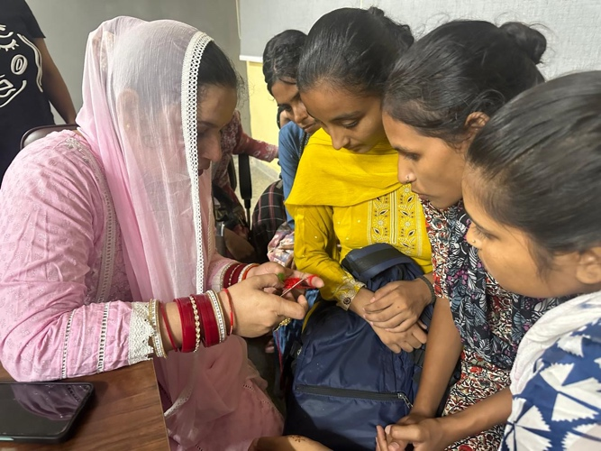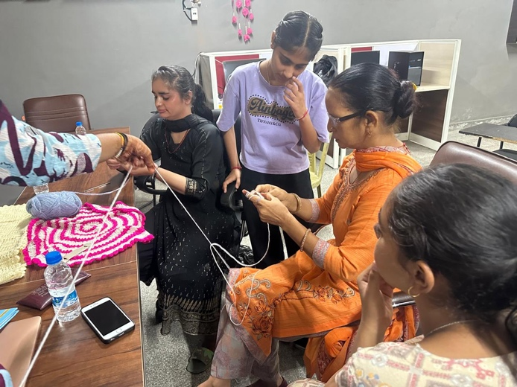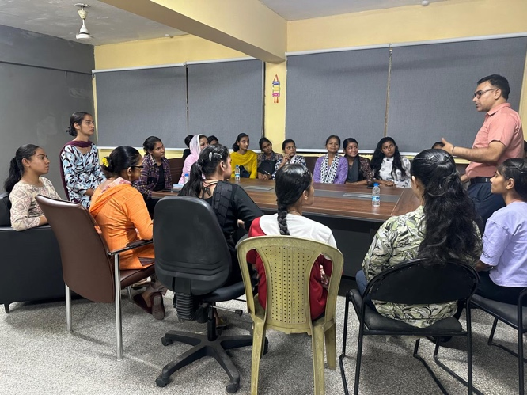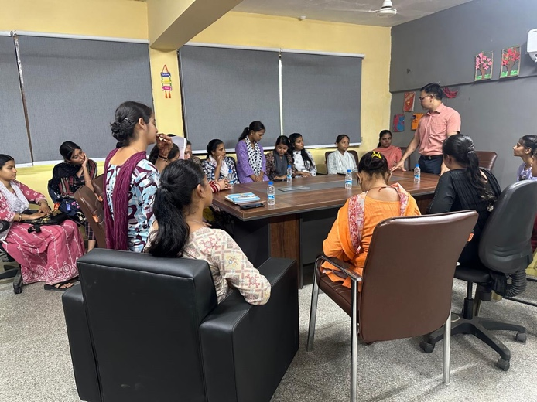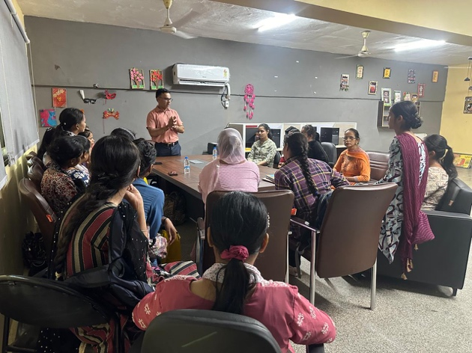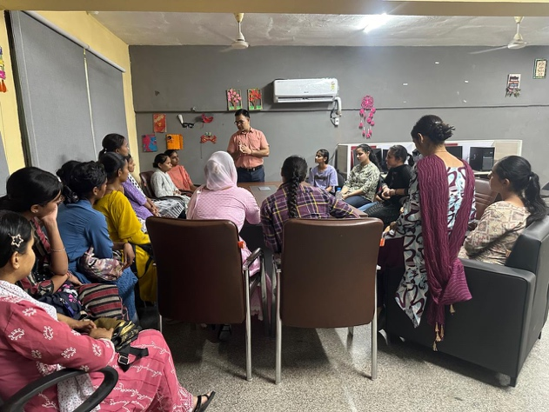

Activity 9 report Date:
Team from Govt post graduate College visited Barwala College a team from start-up incubation Centre of government postgraduate College Sector 1 Panchkula led by Tanushree Chandra Head of the start-up incubation Centre of excellence and Pankaj Singh, external coordinator visited GC Barwala Panchkula. Main purpose of this visit was to inform students about entrepreneurship and the inhibition Centre During this program. They also informed the students about the upcoming state-level competitions that will take place between September 16-20.
This program was coordinated by assistant professor Seema Grewal, computer department and Mr Praveen History department, a large chamber of students participated in the program and gain knowledge about various aspects of entrepreneurship. Tanushree and Pankaj inspired the students to develop new ideas and worked towards creating start-ups.

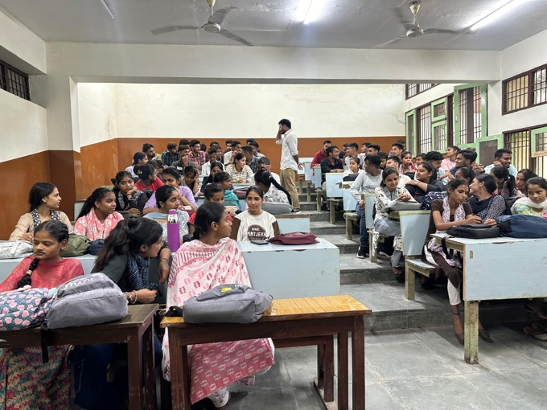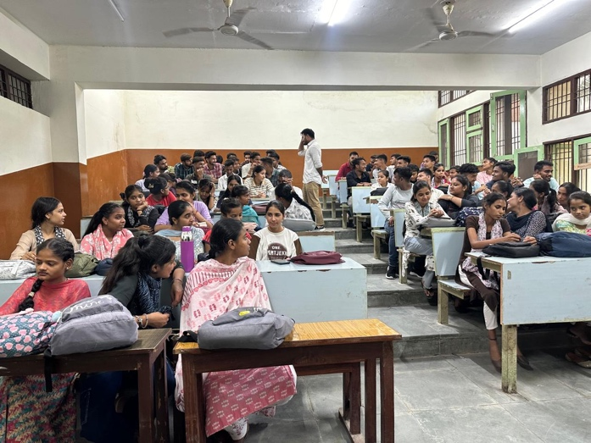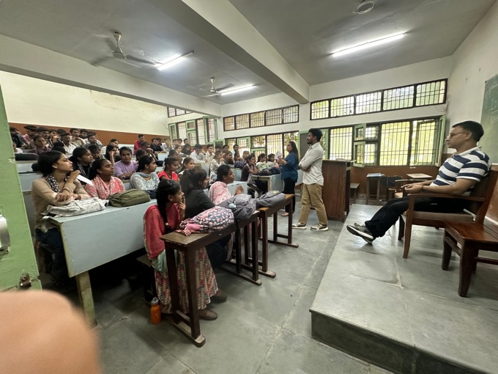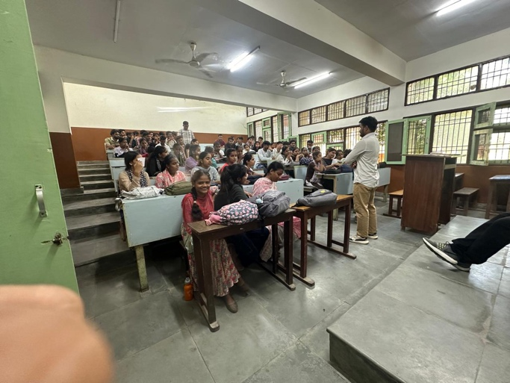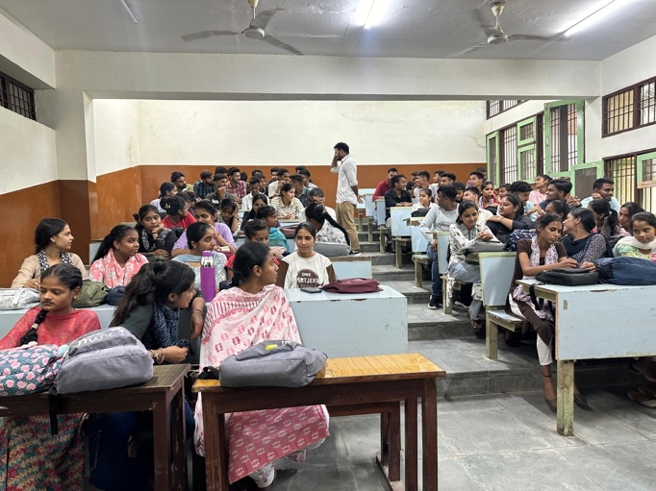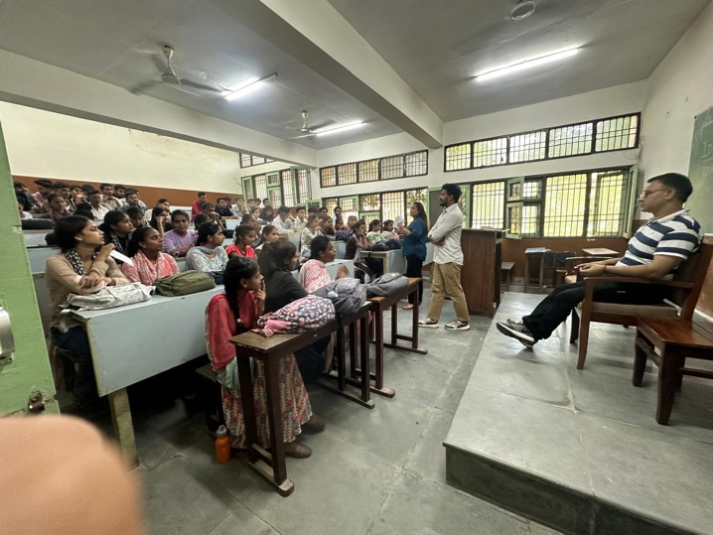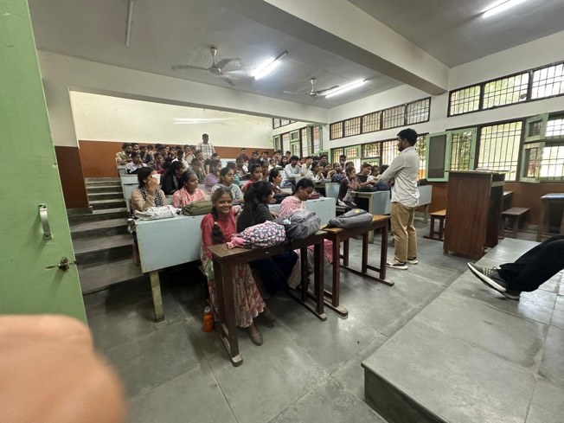
Activity 10 report Date:
Students visited incubation Centre at Govt PG College sector one, Panchkula for idea, Kriti 6.0
Students from government College Barwala visited government, PG College sector one, Panchkula and commission centre for idea Kriti 6.0 and learn about start-ups and upgrade their skills discussed about ideas and how to convert ideas into real business business planning and strategy, product, market fit, customer acquisition and sales final Art of pitching idea, submission, et cetera are covered in this activity.
Three days, Student went to Sector 1 College and due to transport issues three more days, students attended the classes online in Barwala College students like the workshop and learned about how to convert idea into business

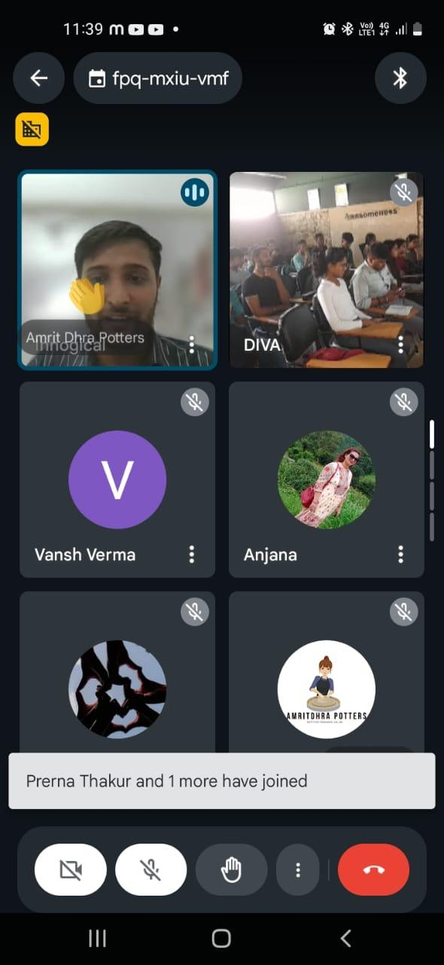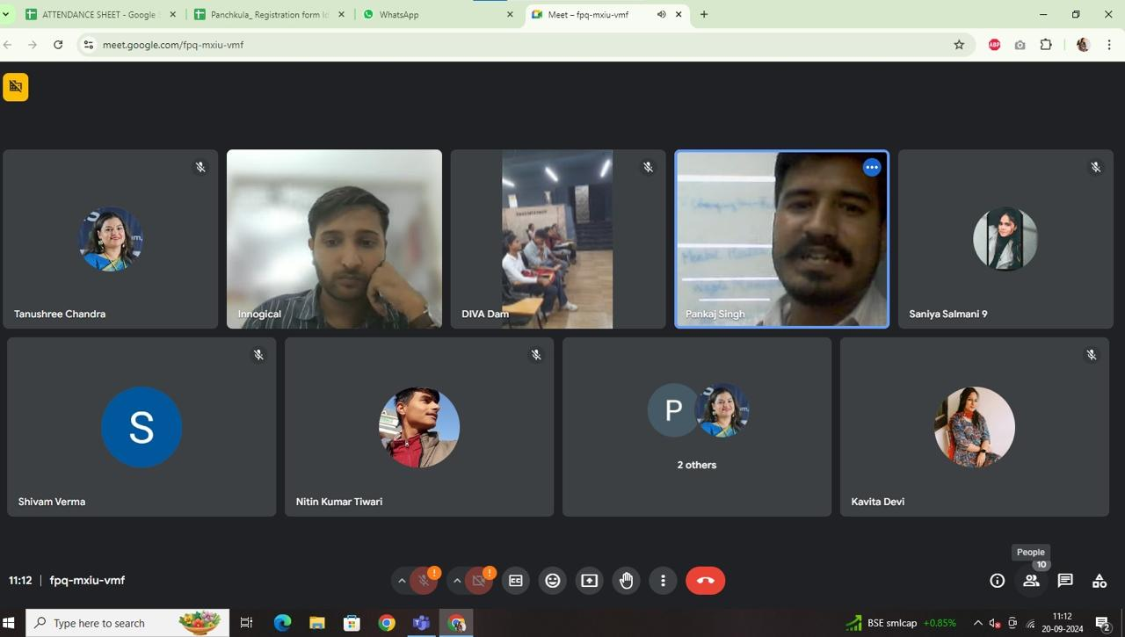
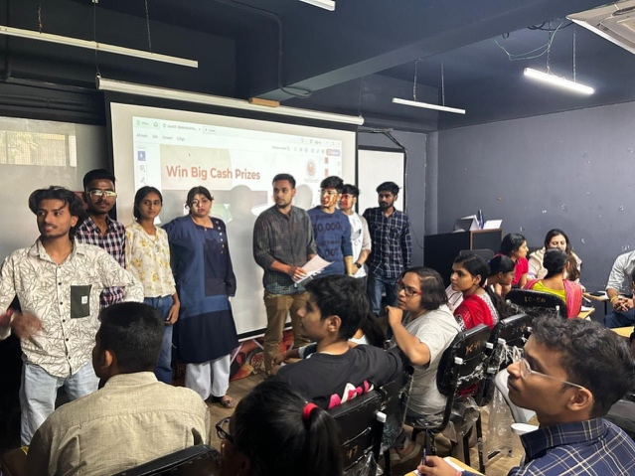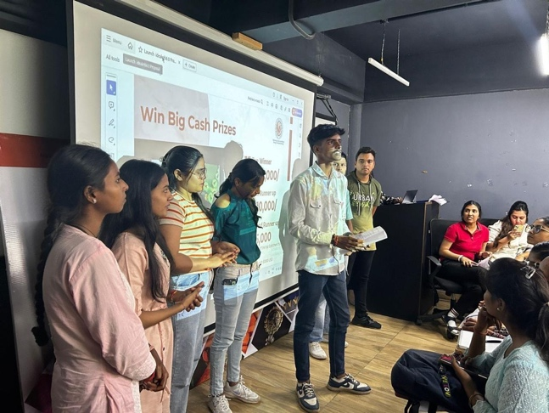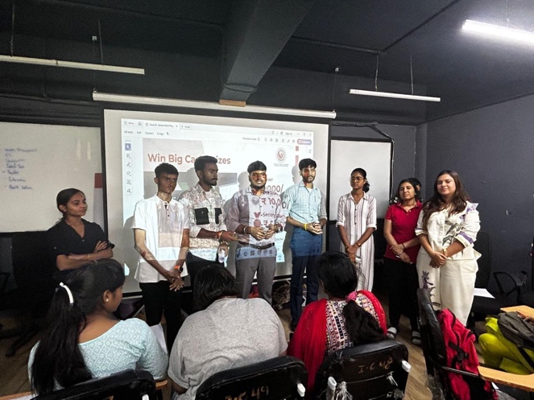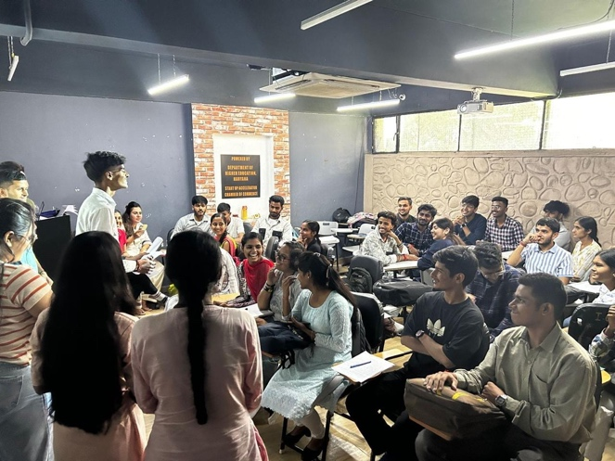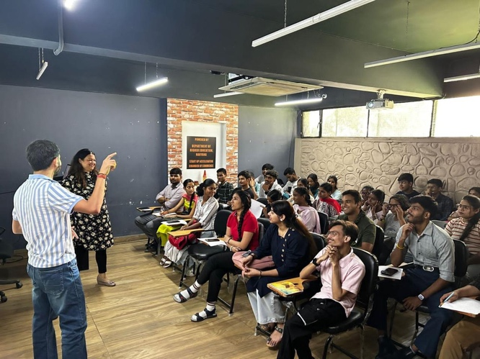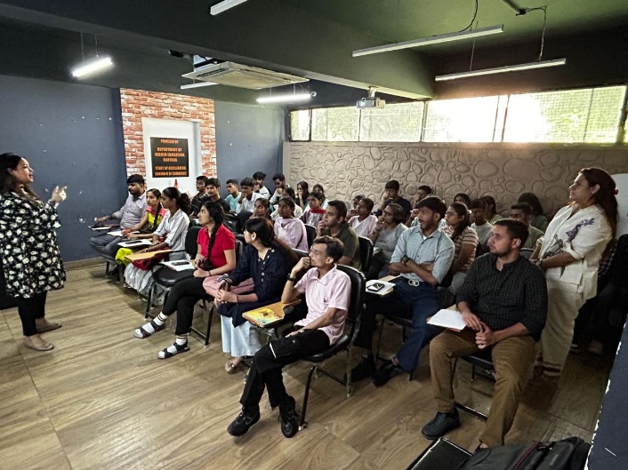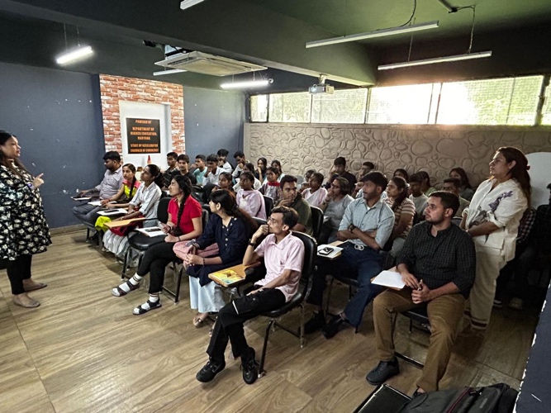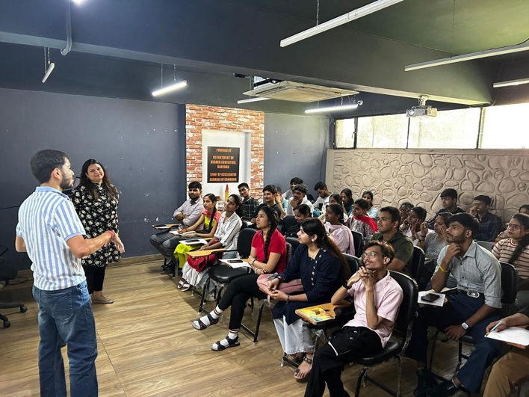

Activity 11 report Date: 27 Sep 2024
Inter College, Sanjhi and terracotta at one day workshop
One day workshop on Sanchi Kota art disorganised in college students from Mata Mansa Devi, Sanskrit Government College, Government College, Raipur Rani Government PG College sector one, Panchkula Government College, sector 14, and Govt College, Morni participated in this workshop
Silk Route NGO from Delhi organised this workshop and total of 62 students participated in this workshop. Students learn how to do sanjhi and terracotta art artist of Sanchi Ram Soni and Dev Soni from Rajasthan and artist of Tera kotta is Ishver Singh from Rajasthan.
30 students participated in sanjhi Art and 30 students participated terracotta art from all colleges

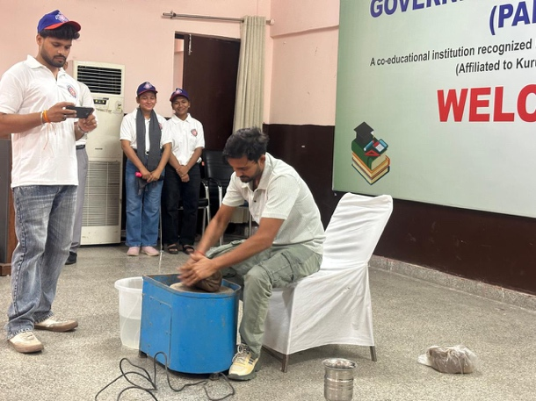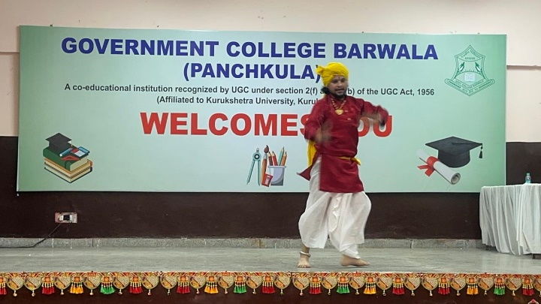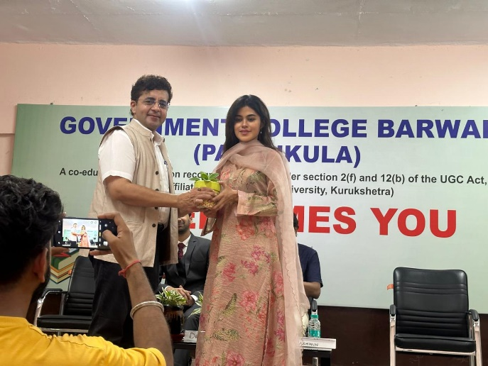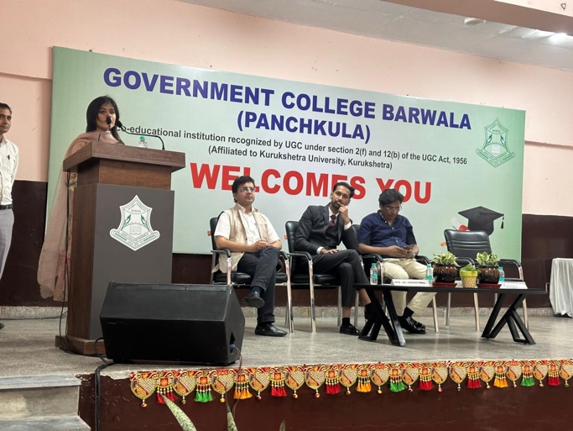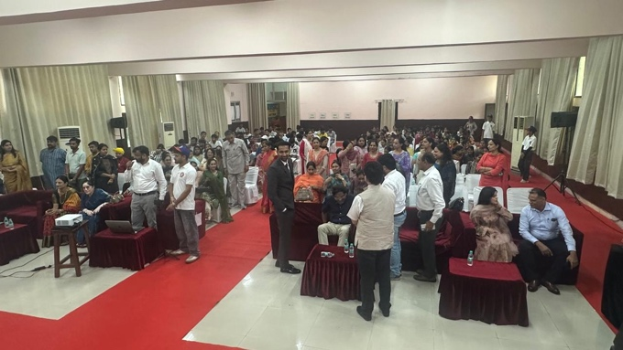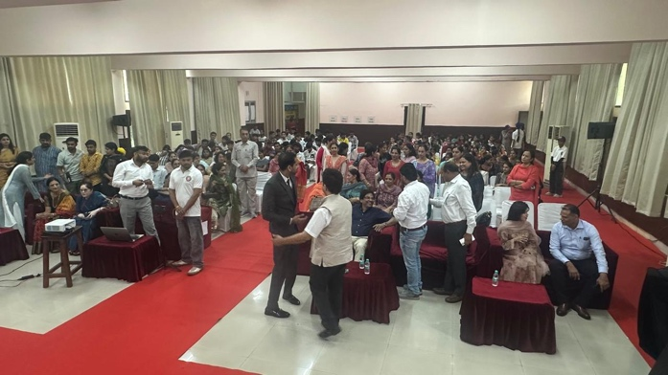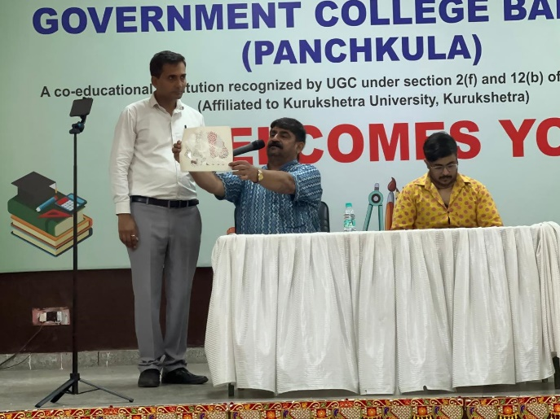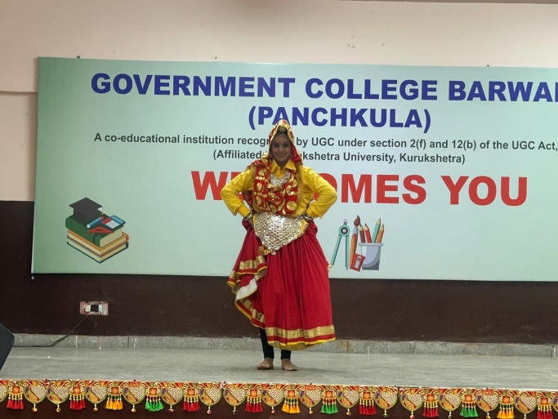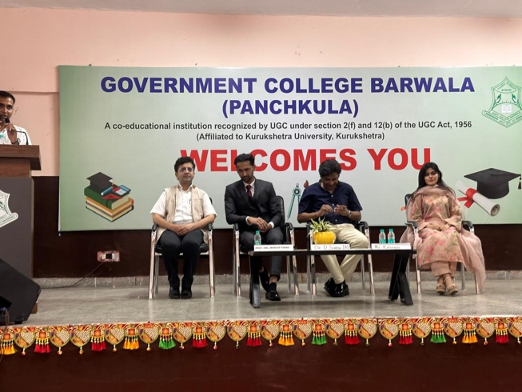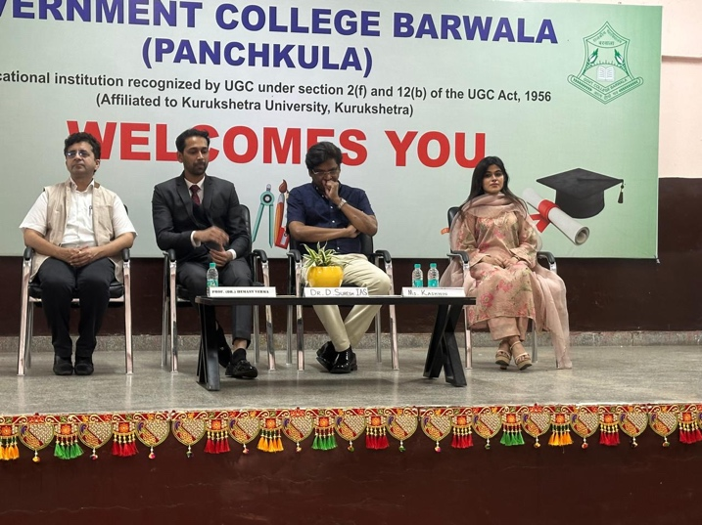

Activity 12 report Date: 19 Oct 2024
Mehendi celebration on the occasion of Karva Chauth
Mali celebration organised in the college on the occasion of Karva Chauth programme was organised by women cell and incubation Centre
Students of college participated in this program and earned money near about 25 students participated in this celebration and presented beautiful designs, one after the other, which made the atmosphere of the event festive
Also, students appreciated and discussed different when they design and art with each other. Different mehendi designs were designed by the students and also this event become source of motivation for student to show their skills and earn from their hobbies.
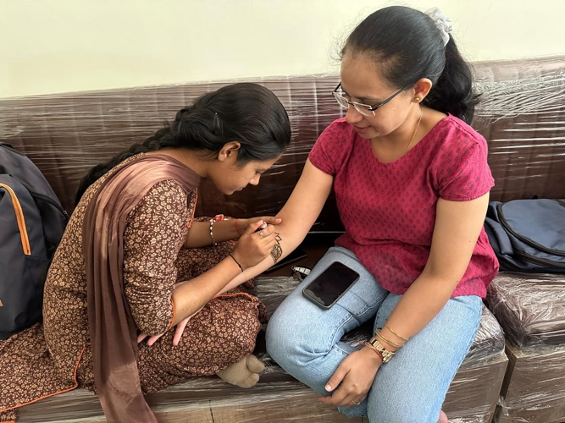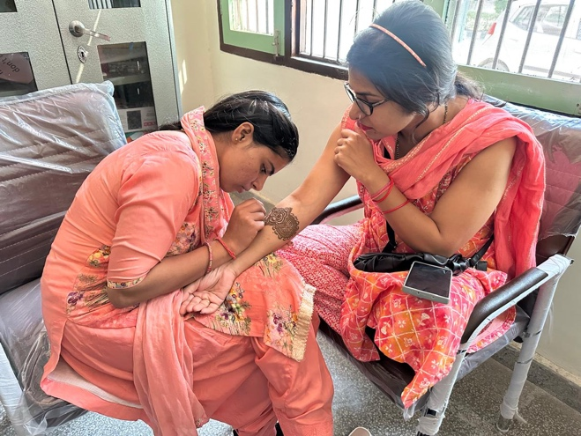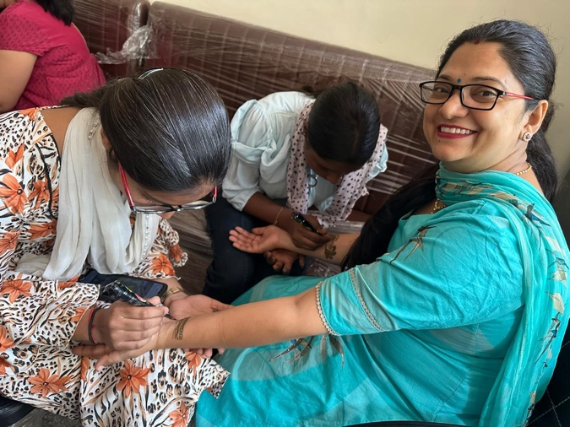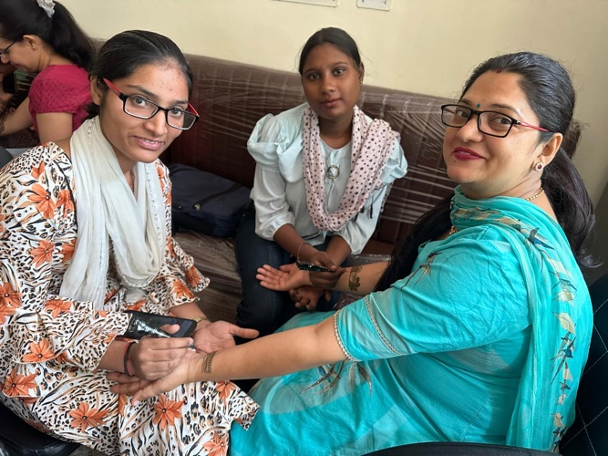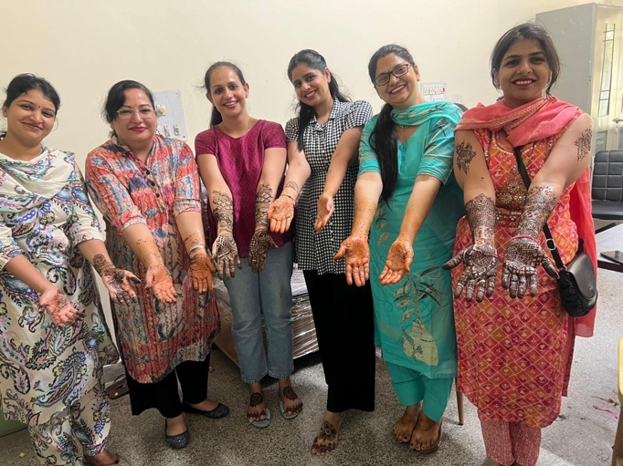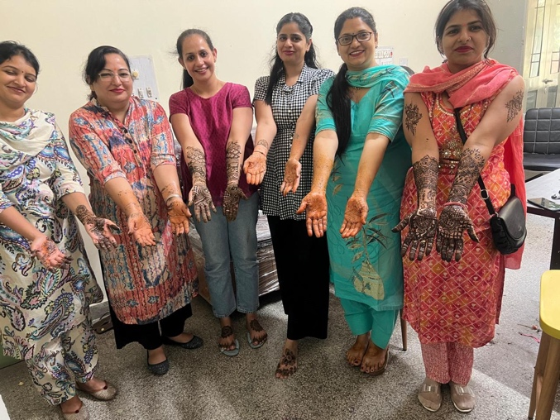

Activity 13 report Date: January 31, 2025
The three-day workshop titled "Artful Outcomes by Heart" was organised by Women Cell in collaboration with Incubation Centre from January 29 to 31, 2025.
This initiative aimed to bridge the gap between artistic creativity and entrepreneurial opportunity, giving students a holistic learning experience that combined artistic techniques with business acumen.The workshop focused on two unique art forms, Paper Mache and Cone Work, with students learning how to transform their artistic passion into viable business opportunities. Artists Anju and Monika from Hisar guided the students, introducing them to intricate techniques and helping them envision art as both a creative expression and a commercial venture.
30 students from diverse academic streams, including Art, Commerce, M.Sc., and B.A., participated in the workshop. The diversity enriched the discussions, with students bringing unique perspectives from their respective fields and helping create an interdisciplinary learning environment. The workshop emphasized how art can be transformed into a commercial product. Students learned how to market and sell their creations, gaining valuable insights into branding and business development.
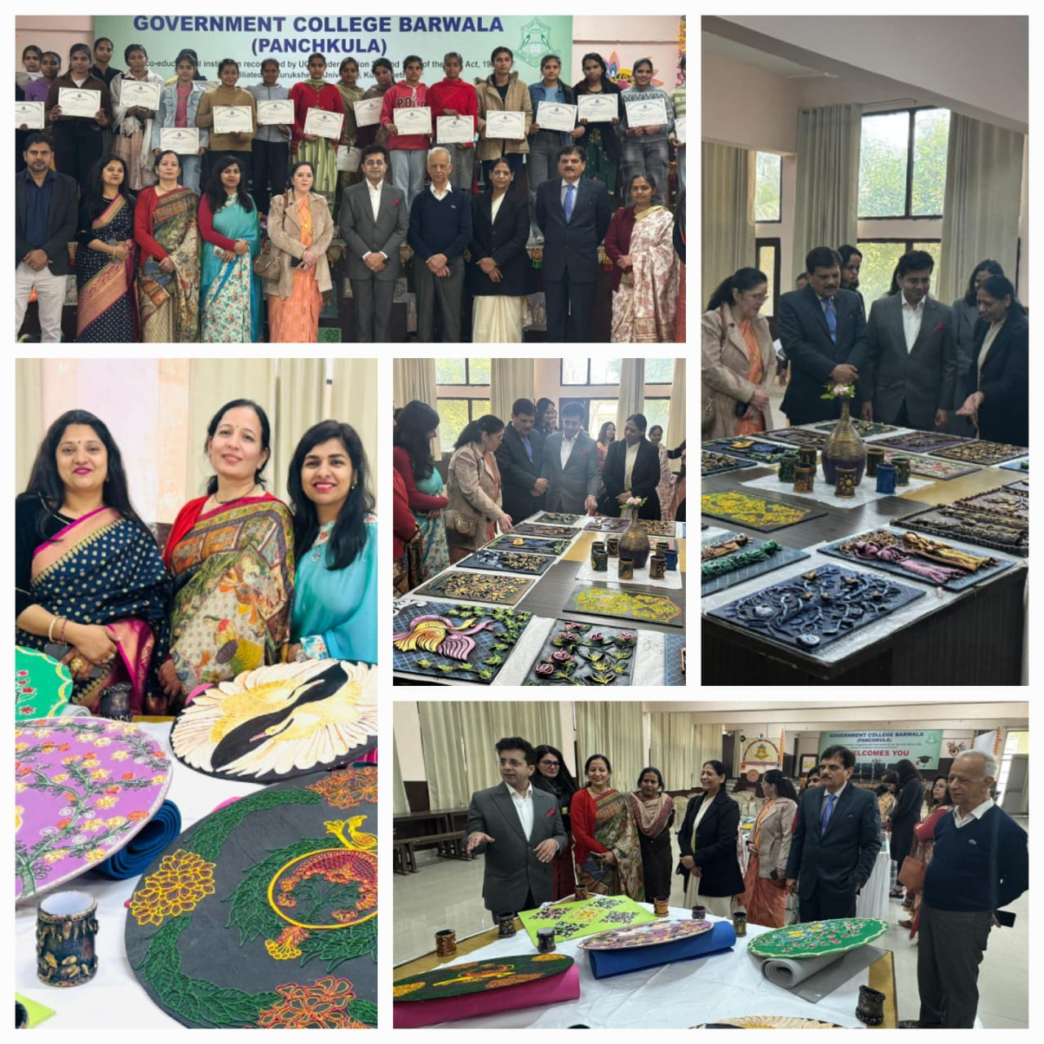
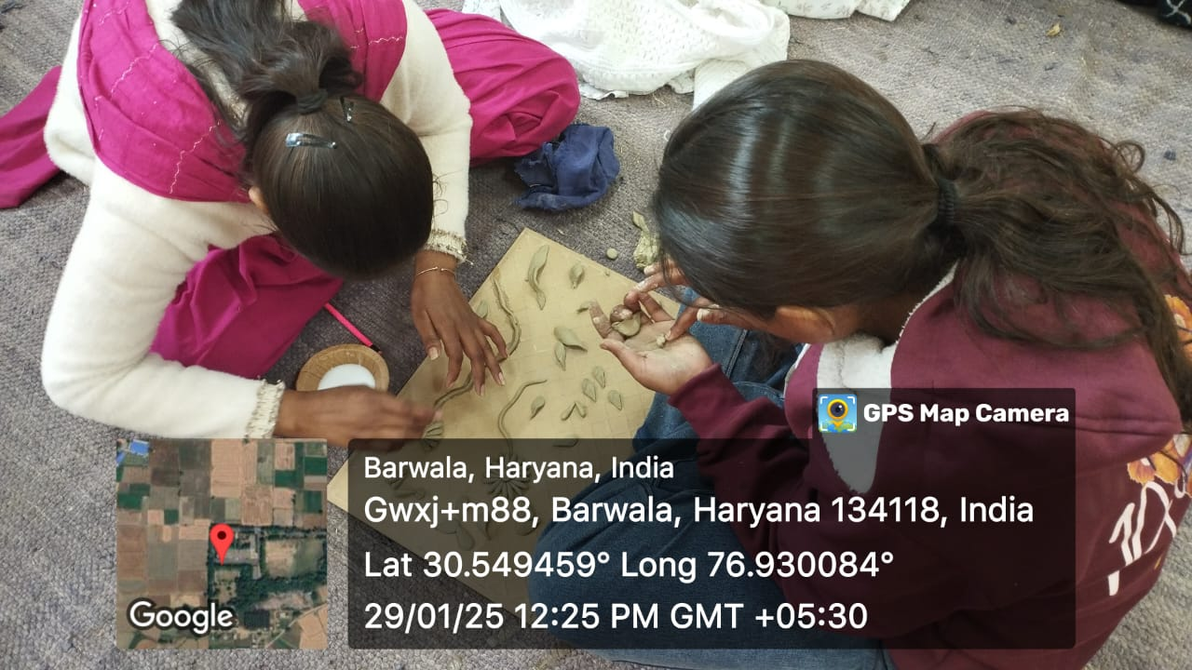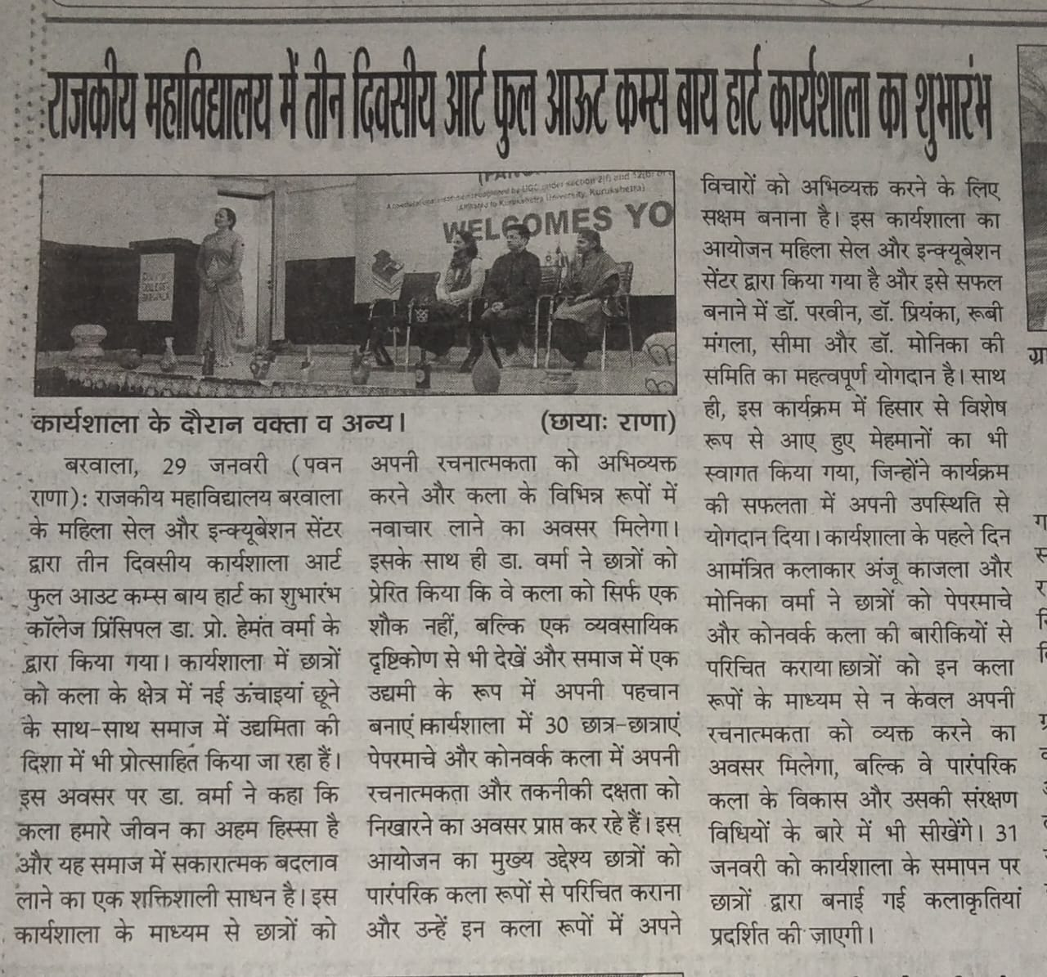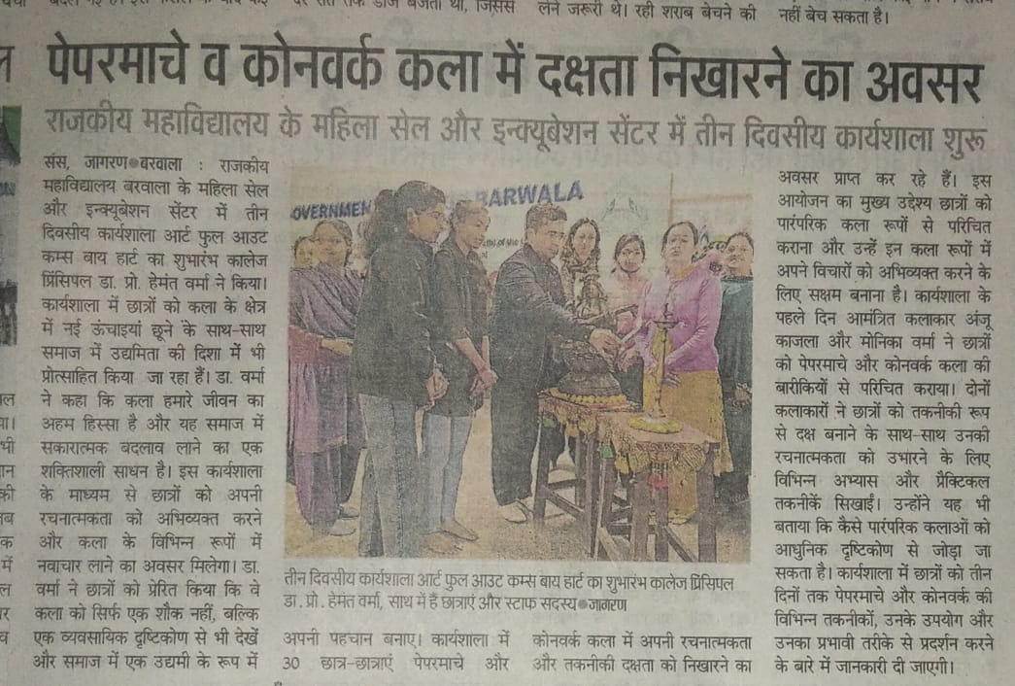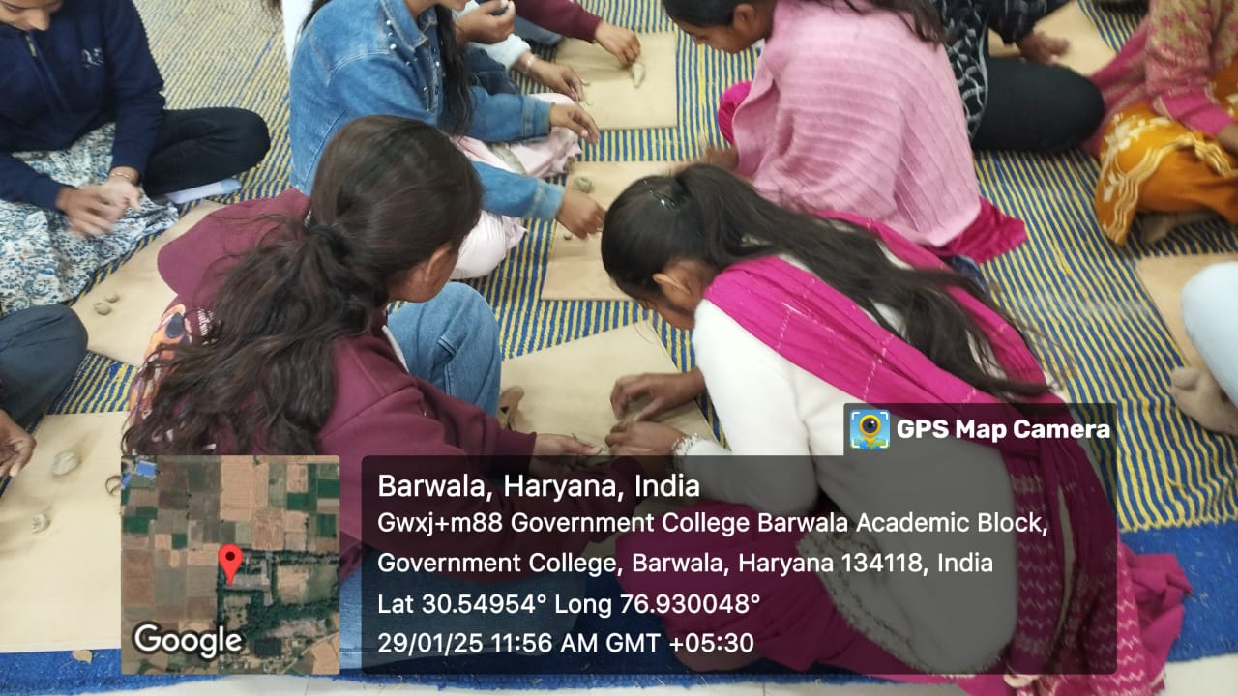

Activity 14 report Date: 24-28 March,2025
IDEAKRITI 7.0, organized by the Incubation Centre, Sector-1 Panchkula, took place from 24th to 28th March 2025. Under the leadership of Convenor Rubi Mangla from Govt. College Barwala, Panchkula, five students participated in the district-level competition on 2nd April 2025. During the event, they not only showcased their innovative ideas but also learned valuable entrepreneurial skills. The team of Sukesh and Mohit secured a spot in the Top 5, highlighting their creativity and problem-solving abilities. The event provided great exposure and learning opportunities for all participants.
